Write a Prolog Program to Sum the Integers from 1 to n

Aim:

To write and execute a Prolog program that calculates the sum of integers from 1 to n using recursion.

Objective:

- To understand recursive programming in Prolog.
- To implement a recursive predicate for finding the sum of natural numbers from 1 to n.
- To verify the correctness of the program with different input values.

Algorithm:

- Start.
- Read the value of n.
- Define the base case:
- If n = 0, return 0.
- Define the recursive case:
- Compute the sum as n + sum(n - 1).
- Continue recursion until the base case is reached.
- Display the calculated sum.
- Stop.

Program:
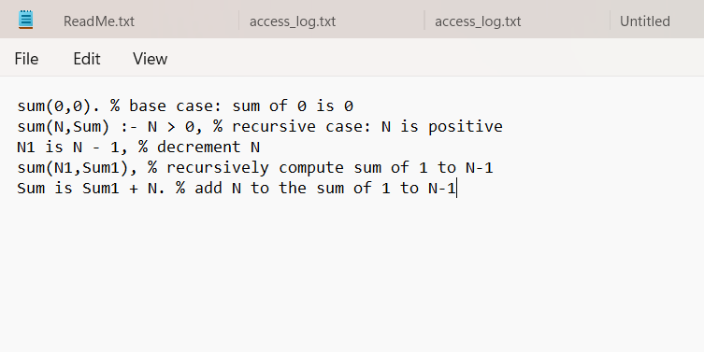
Output:
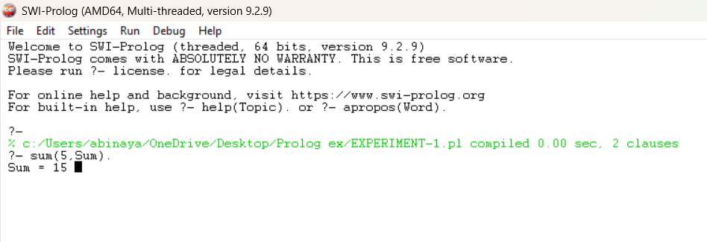

Result:

The Prolog program was successfully executed and correctly computed the sum of integers from 1 to n using recursion. The output matched the expected results for the given test inputs.

